**A COMPREHENSIVE ANALYSIS OF FINANCIAL PERFORMANCE: INSIGHTS**

**FROM A LEADING BANKS**

# 1 . INTRODUCTION

## 1.1 Overview

## Financial performance in broader sense refers to the degree to which financial objectives being or has been accomplished and is an important aspect of finance risk management. It is the process of measuring the results of a firm’s policies and operations in monetary terms. It is used to measure firm’s overall financial health over a given period of time and can also be used to compare similar firms across the same industry or to compare industries or sectors in aggregation.

## Financial statements provide a formal record of a business’ financial activities and position. Financial information is presented in an understandable and structured manner.

Financial Performance Analysis :

Financial performance analysis includes analysis and interpretation of financial statements in such a way that it undertakes a full diagnosis of the profitability and financial analyst program provides vital methodologies of financial analysis.

**Areas of financial performance analysis :**

Financials analysts often assess the firm’s production and productivity performance (total business performance ),profitability performance, liquidity performance, working capital performance, fixed assets performance, fund performance and social performance. Various financial ratios analysis includes

1. Working capital Analysis
2. Financial structure Analysis
3. Activity Analysis
4. Probability Analysis

## The metrics, investors and analysts can gain insights into the bank's financial health, profitability, and growth prospects, and make informed investment decisions. A comprehensive analysis of financial performance also helps identify potential risks and opportunities for the bank, which can inform strategic planning and ensure the long-term success and stability of the bank.

## 1.2 Purpose

Its purpose is to provide stakeholders with accurate and reliable data and information that provide an overview of the company ‘s financial health.

Financial performance analysis includes analysis and interpretation of financial statements in such a way that it undertakes a full diagnosis of the profitability and financial soundness of the business. The financial analyst program provides vital methodologies of financial analysis.

# A financial statement is a collection of data that is organized according to logical and consistent accounting procedures. Its purpose is to convey an understanding of some financial aspects of a business firm.

# 2 . Problem Definition & Design Thinking

# 

# Empathy Map



**3. Activity and screenshort**

1. Top Banks according to Rank and assest.
2. Top Bank according to country based on total assests.
3. Top 10 countries with assest proportion.
4. Country with total assest using funnel chart in increasing order
5. Total assest analysis according to year and quarter
6. Top Banks according to total assest
7. 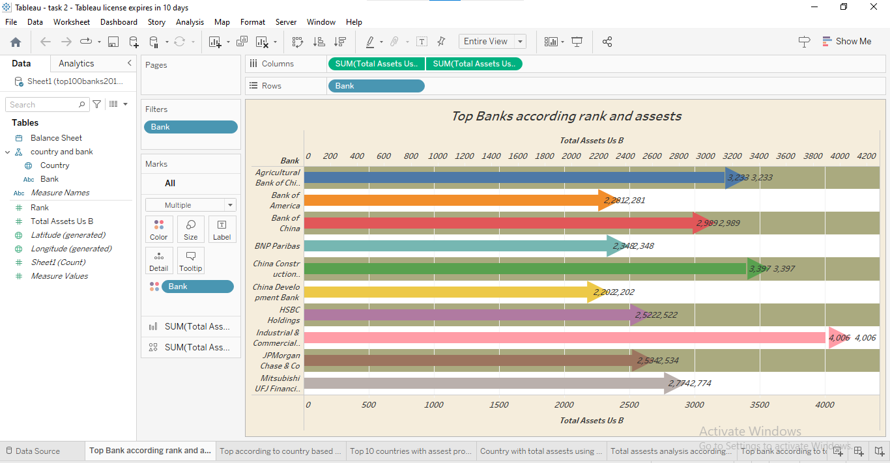

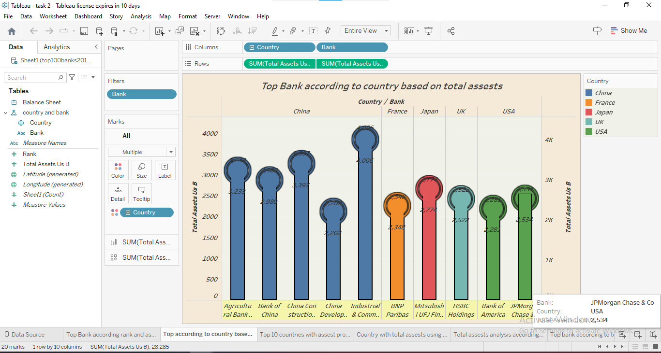

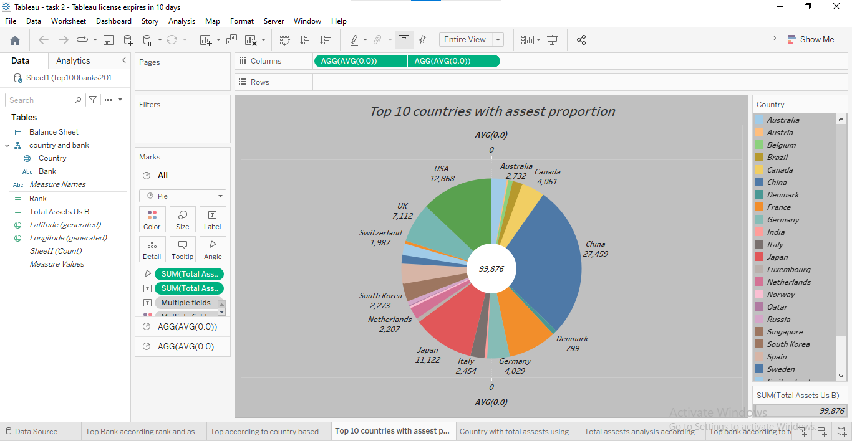

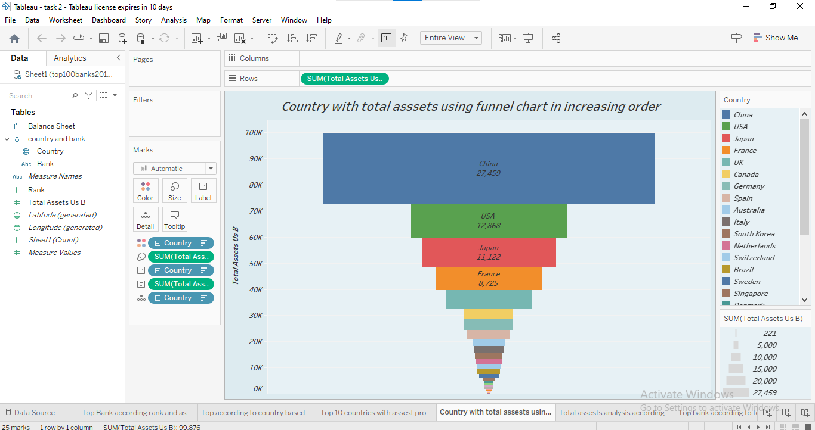

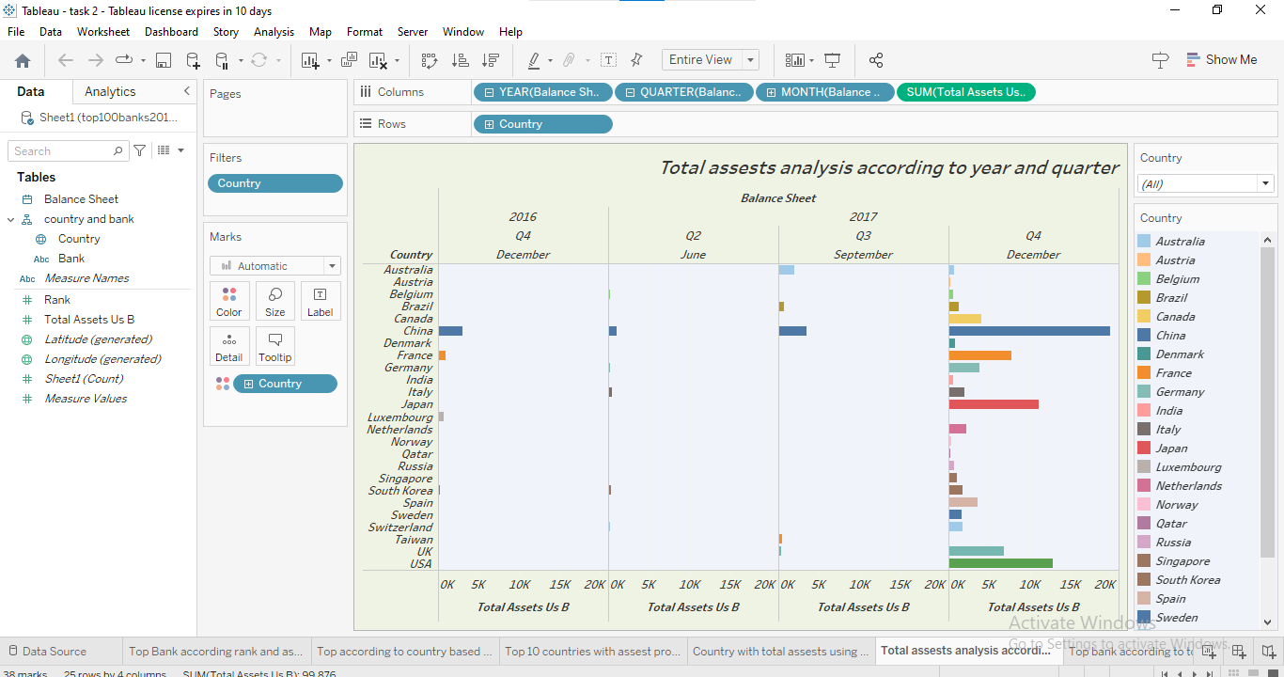

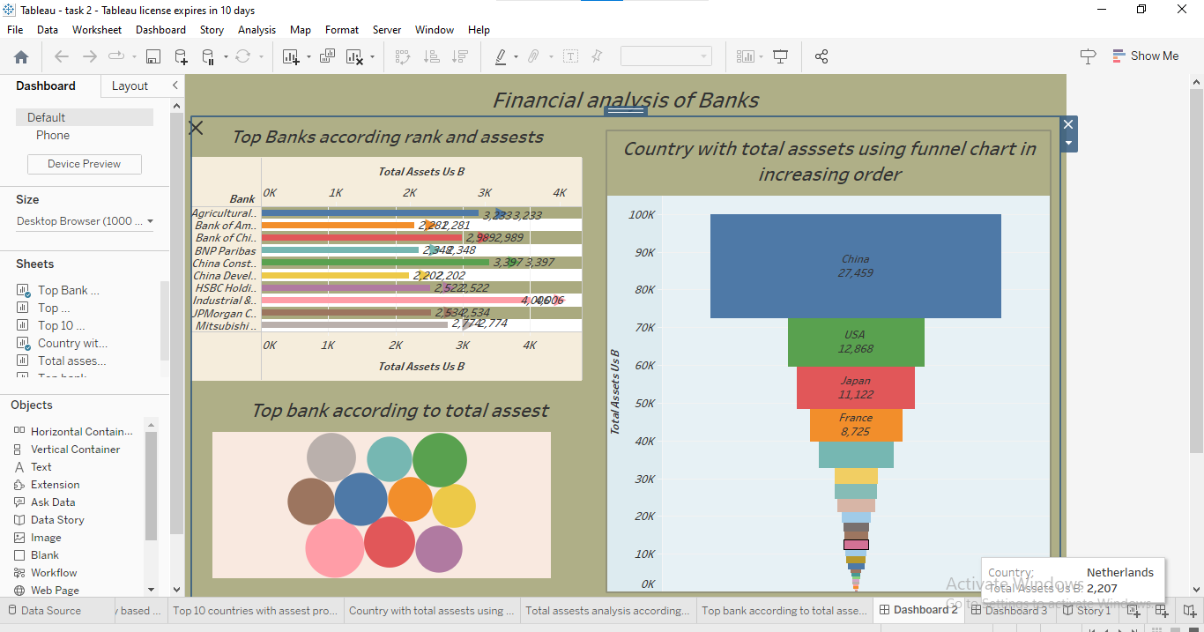

1. **ADVANTAGE**

**The ability to detect patterns :**

Financial statements reveal how much a company earns per year in sales. The sales may fluctuate , but financial planners should be able to identify a pattern over years of sales figures. For example , the company may have a battern of increased sale when a new product is released. the sale may drop after a year or so of being on the market. This is beneficial, as it shows potential and sales patterns so executives know to expect a drop in sales.

**A Chance to budget outline :**

Another advantage of using financial company budgets.

The budgets reveal how much wiggle room the company has to spend on launching products ,developing marketing campaigns or expanding the current office size. Knowing how much money is available for planning and decision making ensures that the company does not spend more than expected.

**Disadvantage:**

**Based on market patterns**

One disadvantage of using financial statement for decision making is that the data figures are based on the market at that given time. Depending on the market, it may change quickly, so executives should not assume that the numbers from a previous financial statement will remain the same or increase. Just because a company has sold year does not guarantee it will sell the same amount or more. It may sell much less if a competitor releases a similar product.

* Problem in comparability
* Reliability of figures change in accounting method
* Change of business condition
* Based of data

**5 . APPLICATIONS**

* Financial analysis can be used to measure a bank's profitability by examining its income statement and assessing its revenue, expenses, and net income.
* Financial analysis can be used to evaluate a bank's asset quality by examining its balance Sheet And Assessing The Quality Of Its Loans And Investments

**6.CONCLUSION :**

A financial performance report is a summary of the financial performance of a company that reports the financial health of a company helping various investors and stakeholders take their investment decision.

**7. FUTURE SCOPE**

analysis financial ratios to assess probability, solvency, working capital management ,liquidity, and operating effectiveness .Compare current performance with historical conditions using trend analysis. Compare with peer companies or industry averages to find out how well companies are performing.

The banking sector mainly recruits for three posts-Clerical cadre, Management and Trainee(MT),and Probationary Officer(PO).Other opportunities in this career path are Financial

Service Representatives, Bank tellers, Bill and Account Collectors, Loan Officers, Financial Managers, Bookkeeping, and Audit clerks.

A financial analysis will not only help you understands yours company financial condition, helping you determine its creditworthiness, probability and ability to generate wealth ,but will also provide you with a more in –depth look at how well it operates internally.